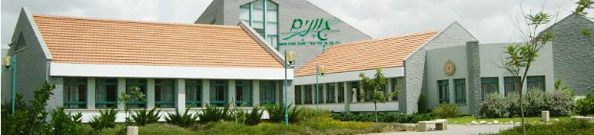

Name:______________
Class:_______________
את התשובות יש לשלוח לרג'ין למייל: regingine@gmail.com
עד לתאריך 25.02.14 שעה
בהצלחה צוות אנגלית
בית-הספר גוונים

Communication (תקשורת) with Morse Code

- Look at the pictures below.
- What do these pictures have in common?

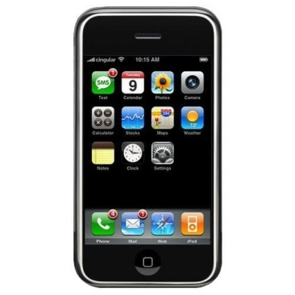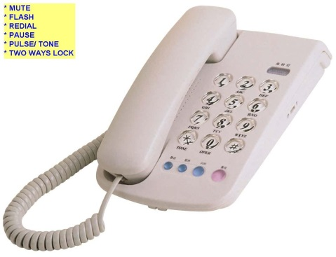

C. Circle the correct answer:הקף את התשובה הנכונה
1) Do you have friends or family who live far away (רחוק)? Yes/ No

2) How do you talk to them?

a. sms b. WhatsApp c. cell phone d. E-Mail

D. You are going to read about how people who lived far away communicated(תקשרו)
with each other many years ago.

E. vocabulary

ways – דרכים
Communicate – לתקשר
Far away – רחוק
Video calls –שיחות וידאו
Text message – הודעת טקסט
Post message – לפרסם הודעה
Website – אתר אינטרנט
All over the world – בכל רחבי העולם
Stay in touch – שמרו על קשר
Post –לשלוח
Slow – איטי
For instance- לדוגמא
Dot – נקודה
Dashe – מקף
Code – צופן
Immediately - מיד

F. Read the story, then answer the questions.קיראו את הסיפור וענו על השאלות

There are many ways to communicate with people who are far away. We can speak on the telephone. We can even make video calls using MSN or Skype on the internet. Some people send emails. Some people write letters. Some write text messages. Some post on websites like Facebook and Hi5. In 2014, it’s easy to talk with friends from all over the world.

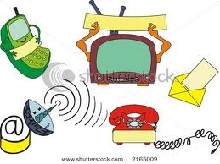

What did people do 150 years ago? There were no computers, no mobile phones, no internet. How did people stay in touch?

Many people used to write letters and post them.
But this was very slow. It often took weeks to send a letter.
But in 1859, the American Samuel Morse invented Morse Code. His code was made of dots and dashes. The dots and dashes represented different letters. For instance the letter A was made of a dot and a dash (.-). People liked it because you could send a message in Morse Code and get a reply almost immediately.

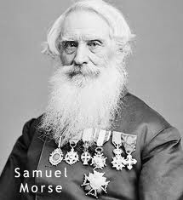

Morse Code made of dots and dashesקוד מורס – נקודות ומקפים המייצגים אותיות

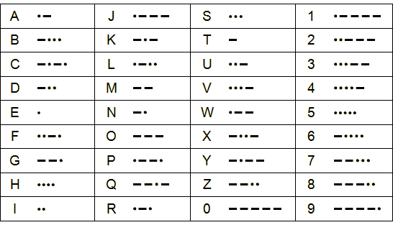

Part B: Answer True or False.כיתבו אם המשפט הוא נכון או לא נכון

1. Samuel Morse was born in America.

2. People used to talk on the telephone 150 years ago.

3. Morse Code is made from dots and dashes.

4. Morse Code was invented in 1859.

Part C: Answer the questions. ענו על השאלות

1. How do people communicate with each other today?

_________________________________________________________________________________

2. Before Morse Code, how did people communicate with friends who lived far
away?

3. When was Morse code invented?

4. Where did Samuel Morse come from?

___________________________________________________________________________

5. Why did people like Morse Code?



Good Luck
Regine

